MON NOV 2  BREAKFAST LUNCH  BREAKFAST KIT BBQ MEATBALLS 6EA  CINN TOAST 2OZ GREEN BEANS 3/4C  FRESH APPLE 1EA DICED PEARS 1/2C  MILK 8OZ W/G DINNER ROLL 2OZ  MILK 8 OZ | TUES NOV 3  BREAKFAST LUNCH  STRAW BAGEL 2.5OZ HAMBURGER 2OZ  CREAM CHEESE 1OZ CHEESE 1OZ  BANANA 1EA PEAS&CARROTS 3/4C  FRUIT JUICE 1/2C APPLESAUCE 1/2C  MILK 8 OZ W/G HAM BUN 2OZ  MILK 8 OZ | WED NOV 4  BREAKFAST LUNCH  BREAKFAST KIT W/G CH NUGGETS 6EA  TRIX 1OZ SW POTATOES ¾  CRACKER 1PK TROPICAL FRUIT 1/2C  FRUIT JUICE 1/2C W/G DIN ROLL 2OZ  MILK 8 OZ MILK 8 OZ | THURS NOV 5  BREAKFAST LUNCH  FRUIT MUFFIN 2OZ BEEF PASTA 1C  FRUIT YOGURT 4OZ BEEF 2OZ  FRUIT JUICE 1/2C SAUCE 1OZ  FRESH PEAR 1EA CORN 3/4C  MILK 8 OZ PINEAPPLE 1/2C  W/G BR STICK 2OZ  MILK 8OZ | FRI NOV 6  BREAKFAST LUNCH  BREAKFAST KIT BEEF DIPPERS 6EA  COCO PUFF 1OZ CARROTS 3/4C  CRACKER 1PK MIXED FRUIT 1/2C  FRUIT JUICE 1/2C W/G BR SLICE 2OZ  FRESH APPLE 1EA MILK 8 OZ  MILK 8 OZ
MON NOV 9  BREAKFAST LUNCH  CRACKER 1PK W/G MAC & CHEESE 1C  FRUIT YOGURT 4OZ GREEN BEANS 3/4C  FRUIT JUICE 1/2C APPLESAUCE 1/2C  APPLE 1EA W/G DIN ROLL 2OZ  MILK 8 OZ MILK 8 OZ | TUES NOV 10  BREAKFAST LUNCH  BREAKFAST KIT FISH SANDWICH 3OZ  APPLE JACKS 1OZ CORN 3/4C  CRACKER 1PK APPLE SLICES 1/2C  FRUIT JUICE 1/2C W/G HAM BUN 2OZ  FRESH BANANA 1EA MILK 8 OZ  MILK 8 OZ | WED NOV 11  BREAKFAST LUNCH  BREAKFAST KIT BBQ DICED CHICKEN 3OZ  CINN TOAST 1OZ MIX VEG 3/4C  FRUIT JUICE 1/2C DICED PEACHES 1/2C  CRACKER 1PK W/G HAM BUN 2OZ  ORANGE 1EA MILK 8 OZ  MILK 8 OZ | THURS NOV 12  BREAKFAST LUNCH  FRENCH TOAST 1PK NACHO CHIPS 2OZ  FRUIT JUICE 1/2C TACO MEAT 2OZ  FRESH PEARS 1EA REFRIED BEANS 3/4C  MILK 8 OZ LIQ CHEESE 1OZ  FRUIT CUP 1/2C  W/G DIN ROLL 2OZ  MILK 8 OZ | FRI NOV 13  BREAKFAST LUNCH  BREAKFAST KIT CHICKEN ALFREDO 1 C BANANA 1EA DICED CHICKEN 2OZ  CIN POPTART 1PK PEAS 3/4C  FRUIT JUICE 1/2C TROPICAL FRUIT 1/2C  CRACKER 1PK W/G BR STICK 2OZ  MILK 8 OZ MILK 8 OZ
MON NOV 16  BREAKFAST LUNCH  CIN BAGEL 2OZ W/G CH PATTY 3OZ  FRUIT JUICE 1/2C MIX VEG 3/4C  APPLE SLICES 1/2C FRUIT CUP 1/2C  CR CHEESE 1OZ W/G HAM BUN 2OZ  MILK 8 OZ MILK 8 OZ | TUES NOV 17  BREAKFAST LUNCH  BREAKFAST KIT TACO MEAT 2OZ  COCO PUFF 1O REFRIED BEANS 3/4C  CRACKER 1PK SHRED LETTUCE 1/4C  FRUIT JUICE 1/2C SHRED CHEESE 1OZ  BANANA 1EA MANGO 1/2C  MILK 8 OZ W/G TORTILLA 2EA  MILK 8 OZ | WED NOV 18  BREAKFAST LUNCH  PANCAKE 1PK BEEF RAVIOLI 1C  SYRUP 1PK GREEN BEANS 3/4C  FRUIT JUICE 1/2C TROPICAL FRUIT 1/2C  ORANGE 1EA W/G BR STICK 2OZ  MILK 8 OZ MILK 8 OZ | THURS NOV 19  BREAKFAST LUNCH  BREAKFAST KIT IT MEATBALLS 6EA  LUCKY CHARMS 1OZ CORN 3/4C  CRACKER 1PK PINEAPPLE 1/2C  FRUIT JUICE 1/2C W/G SUB BUN 2OZ  PEAR 1EA MILK 8 OZ  MILK 8 OZ | FRI NOV 20  BREAKFAST LUNCH  BAGEL 2 OZ SCRAMBLED EGGS 2OZ  FRUIT JUICE 1/2C TURKEY SAUSAGE 2OZ  CR CHEESE 1OZ ROAST POTATO 3/4C  BANANA 1EA FRESH MELON 1/2C  MILK 8 OZ CINNOMON BREAD 1 SL  MILK 8 OZ
MON NOV 23  BREAKFAST LUNCH  BREAKFAST KIT 2OZ SLOPPY JOES 3OZ  COCO PUFFS 1OZ CORN 3/4C  CRACKER 1PK MIXED FRUIT 1/2C  FRUIT JUICE 1/2C W/G HAM BUN 2OZ  FRESH APPLE 1EA MILK 8 OZ  MILK 8OZ | TUES NOV 24  BREAKFAST LUNCH  BAGEL 2OZ BEEF HOT DOG 2OZ  CR. CHEESE 1OZ VEG BAKED BEANS 3/4C  FRUIT JUICE 1/2C FRESH PEAR 1EA  FRESH BANANA 1EA W/G HD BUN 2OZ  MILK 8 OZ MILK 8OZ | WED NOV 25   | THURS NOV 26  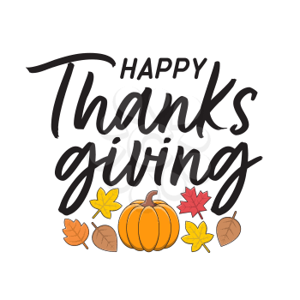 | 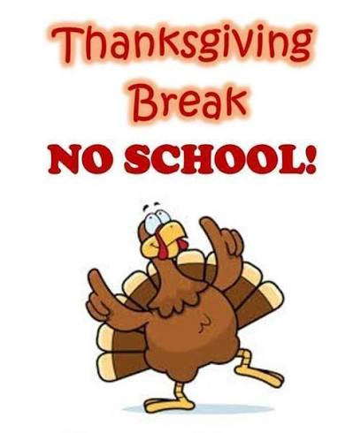  FRI NOV 27

Non-Discrimination Statement: In accordance with Federal civil rights law and U.S. Department of Agriculture (USDA) civil rights regulations and policies, the USDA, its Agencies, offices, and employees, and institutions participating in or administering USDA programs are prohibited from discriminating based on race, color, national origin, sex, disability, age, or reprisal or retaliation for prior civil rights activity in any program or activity conducted or funded by USDA. Persons with disabilities who require alternative means of communication for program information (e.g. Braille, large print, audiotape, American Sign Language, etc.), should contact the Agency (State or local) where they applied for benefits. Individuals who are deaf, hard of hearing or have speech disabilities may contact USDA through the Federal Relay Service at (800) 877-8339. Additionally, program information may be made available in languages other than English. To file a program complaint of discrimination, complete the USDA Program Discrimination Complaint Form, (AD-3027) found online at: http://www.ascr.usda.gov/complaint_filing_cust.html, and at any USDA office, or write a letter addressed to USDA and provide in the letter all of the information requested in the form. To request a copy of the complaint form, call (866) 632-9992. Submit your completed form or letter to USDA by: MAIL: U.S. Department of Agriculture, Office of the Assistant Secretary for Civil Rights, 1400 Independence Avenue, SW FAX: (202) 690-7442 EMAIL: program.intake@usda.gov “This institution is an equal opportunity provider.”

